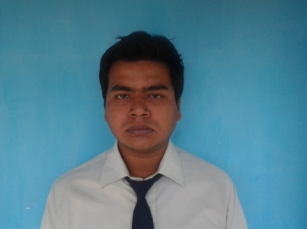**CURRICULUM VITAE**

**AMIT MAJUMDER**

Daulatpur, P.O.-Pailan,Dist.-24 Pg (S.), Kol-700104

Contacts :-+91 9163339783

Email Id :

[a.m.calcutta1990@gmail.com](mailto:a.m.calcutta1990@gmail.com)

**CAREER OBJECTIVE**

I’m seeking for a suitable position in a reputable organization where I can increase my skills through hard working with putting my best effort in the growth of the organization.

**SKILL SET**

* A go-getter, aggressive with creative mind set ready to move for any fresh assignment
* A team worker and willing to work in any challenging environment
* An effective communicator with exceptional relationship management skills and self-motivator

|  |  |  |
| --- | --- | --- |
| **Core Functional Strengths** | | |
| Sales Management | Marketing Management | Logistical Management |
| Product & service Management | Human Resource Management | Market research |
| Financing | Sales Promotion | Creative Design |

**STRENGTHS**

* Achievement oriented with excellent communication, training, presentation & interpersonal skills
* Detail-oriented, multi tasked, strong, learning and organizing skills matched with the ability to manage time and people effectively
* A good team player with an ability to lead a team by example and motivate them to achieve desired objectives.
* Adept in forecasting and planning, always alert to market needs and change with a knack of picking up local language fast.
* 100% Adaptive to local market environment, Complete knowledge about each market cluster, territory and the demography of regional territory
* Strongly believes in – ‘Leadership is set by examples’

**COMPUTER KNOWLEDGE**

Proficient in MS-Office (MS - Word, Excel, Power Point Presentation) & the Internet

**PROFESSIONAL SYNOPSIS**

* Feb,2014- April,2014 IMOS TECHNOLOGIES PVT. LTD.
* Position :Marketing Officer Location:Kolkata
* Responsibility:Salestater pump automation system and energysaver
* May, 2014- July,2014SEVEN POINT MOTORS (An Authorized Distributor of TVS)
* Position: Area Coordinator Location:Kolkata
* Responsibility:Sale scooter through under my team
* Aug,2014-Dec,2016HYGICARE PRODUCTS(Clinyle)
* Position:Marketing Officer Location:Kolkata&24Pgs(s)
* Responsibility: Appointing new stockiest and handle the existing ones

**ACADEMIC QUALIFICATIONS**

Masters in Business Administrations 2012-2014 WBUT 6.44 CGPA

(Major:Mktg, Minor:HR)

Bachelors in Business Administrations 2009-2012 WBUT 6.17 CGPA

**PROJECTS AND ACCOLADES**

* Title : Sales Promotion and Activity of TVS Scooty

TVS MOTOR LTD; 01/06/2013 – 31/07/2013

* Title : Ratio Analysis

ICICI BANK; 14/03/2012 - 14/04/2012

**PERSONAL DETAILS**

Date of Birth : 20/05/1990

Gender : Male

Father’s name : SUBHAS MAJUMDER

Nationality : INDIAN

Language Known : English, Hindi & Bengali.

DATE: ………………………………………

(AMIT MAJUMDER)

**\*\*\*\*\***